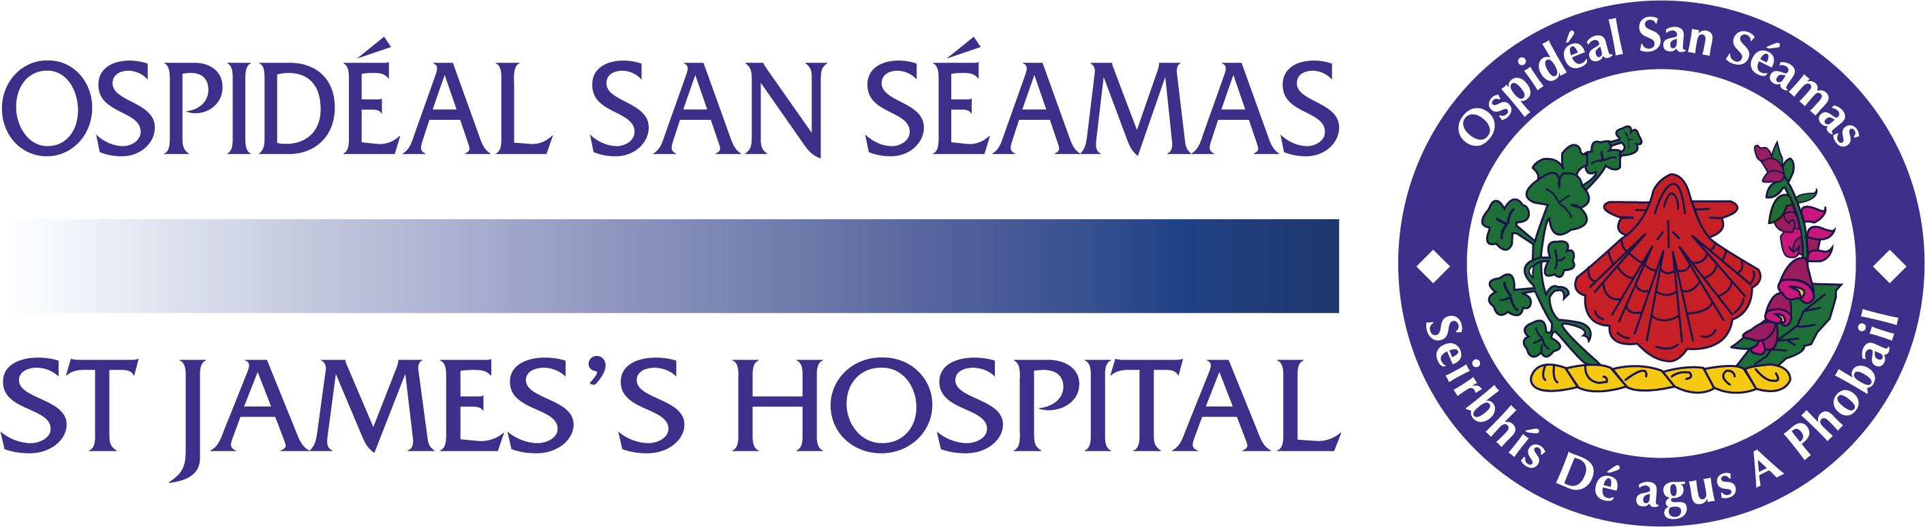
Relocation benefits package agreement form

Candidates who are recruited from outside the Island of Ireland may qualify for some or all of the benefits below, following the commencement of employment with St James’s Hospital. This package is effective from 1 January 2025 to 31 December 2025.

Approved relocation package | EU/UK candidate | Non-EU candidate
payable to candidates | payable up to | payable up to
Total allowances paid to
candidates for flight and | €4,160 | €4,710
accommodation

Claims for reimbursement under this package cannot exceed the maximum set out. Proof of payment for flights from the country of origin, relocation expenses, accommodation expenses, visa costs and professional registration will be required for verification and reimbursement purposes. To claim appropriate benefit(s), claimants must complete the Relocation benefits package claim form and attach the appropriate original receipts within six months of commencing their employment with the hospital. An accommodation allowance is paid to the candidate for the first three months only.
The following additional costs are payable on behalf of the candidate:

  - Registration fees

  - Visa fees

  - RCSI Aptitude Test fees

  - POEA (Philippine Overseas Employment Registration)

  - Language testing and examinations for the purpose of registration

  - Recognition fee/ Validation of Qualification fee
  - Return flights up to the value of €250/€800 Is payable to candidates who were recruited on a Specified Purpose Contract of 2-year duration and are returning to their country of origin having completed but not extending their contract.

Agreement

By signing below, you agree to the above terms as they apply under this benefits package. You also agree that in the event of your resignation before the completion of 2 year’s continuous service, or you do not pass your probation/adaptation programme, any amount owing as a result of benefits claimed under this package can be deducted from your final salary payment from the hospital or you will agree to refund it directly to the hospital.

I agree to the above terms and conditions:

Signed: __________________________

Date:

______________________

PRINT NAME:

____________________

Employee Number: ____________

Signed on behalf of the hospital ___________________ Date: ______________________

Any claims received after six months of employment will not be processed

Please note that the terms and conditions of this agreement are subject to Public Service Agreements/ HR circulars

Relocation benefits package claim form

Please ensure all necessary supporting documentation (receipts / vouched expenses) accompanies your application. Failure to provide the required documentation will result in delays in processing for payment.

Name |  | Employee number
Grade |  | Start date
Directorate/ department |  | Manager
Staff member’s contact |  | Staff member email:
number

Candidates recruited from outside the Republic of Ireland will qualify for some/all of the recruitment benefits following the commencement of their employment with St James’s Hospital. For information on revenue guidelines on allowable expenses, see www.revenue.ie.

Claims for reimbursement must be filled out on this form within six months of commencement of employment and original receipts for costs incurred must be presented to the Human Resources Department for verification, and copies retained for audit purposes. Original receipts should include; flight costs paid and the boarding card in the name of the staff member only, a letter of receipt of accommodation expenses paid and proof of professional registration payments.

Include details of claim (e.g. flights | Receipt / Vouched | Amount being claimed per
(to/from) / accommodation expenses / | expenses attached | benefit
NMBI registration fee)
 |  | €
 |  | €
 |  | €
 |  | €
 |  | €
Total amount being claimed |  | €

Have you ever claimed for reimbursement of such benefits previously? YES / NO

If “Yes”, please outline the details: _________________________________________________________

__________________________________________________________________________________

I declare all of the above information is correct and all appropriate receipts are attached. Signature of applicant: ______________________ Date: _______________

HR – Office Use Only

SAP record checked and confirmed: Name, personnel number, start date and grade

__________________/____________________/___________________/_____________________

Please note that the terms and conditions of this agreement are subject to Public Service Agreements/ HR circulars
All receipts attached have been checked and verified: YES |  | / NO
HR decision | Reason |  | Signature of HR Officer/ date –
 |  |  | applicant informed
Application approved
Application ON HOLD
Application rejected

If the application is approved, the HR officer enters information on a monthly spreadsheet and sends it to the Finance Department to be processed:

Flight | Accommodation | Allowances | Other expenses | Professional | Total amount
 |  |  |  | registration | approved
€ | € | € | € | € | €


HR officer signed ______________________

HR supervisor: ___________________________

Date: ________________

Approved stamp – HR

Business Teams:

Please email this form to: relocationliaisonsupport@stjames.ie

Please note that the terms and conditions of this agreement are subject to Public Service Agreements/ HR circulars

